CASE FILE 05
Polar Pop Cameras
Product line: instant cameras
Polar Pop makes instant cameras that print a photo seconds after you take it. Sales are growing, and Polar Pop thinks one camera can't fit all the different people buying it.
Your job: Build a lineup of three versions, one for each segment below. For every version, choose its features and set its price. Your goal is the most total profit across all three.
THE MARKET: THREE SEGMENTS
Polar Pop Cameras surveyed people in the Chicago area. The survey split them into three groups. Read the profiles, then give each segment a name.
SEGMENT A  12,000 potential customers | SEGMENT B  2,500 potential customers | SEGMENT C  4,000 potential customers
- Ages 13 to 24, uses it at birthdays, dances, and trips  - Covers dorm and bedroom walls with prints  - Often asks for it as a gift  “Phone pics disappear. These go on my wall.” | - Wedding and party planners, photo booth companies  - Hands the camera to hundreds of guests  - Needs it to work all night without a dead battery  “It has to survive 200 wedding guests.” | - Ages 18 to 40, already owns a 'real' camera  - Shares film photos in online photography groups  - Wants control over every shot  “Auto mode is for amateurs.”
Our name for them: | Our name for them: | Our name for them:
PRODUCT BASICS
Base cost of every version | $22 per camera, before any features are added
Price options | $45 $60 $80 $110 $150 $200 (each version must use one of these prices)
WARM-UP: READ THE DATA FIRST
1. Which segment has the most must-have features (60% or higher)? How many does it have?

2. What is the most expensive feature on the menu? Which segment, if any, says it is a must-have?

3. What is the lowest price at which fewer than half of Segment B would buy?

4. If Polar Pop Cameras sold a version with a Fit of 100% to Segment A at $60, how many people would buy it?

SURVEY RESULTS: WHAT EACH SEGMENT REQUIRES
Question asked: “Which of these would a instant camera need to have before you would buy it?”
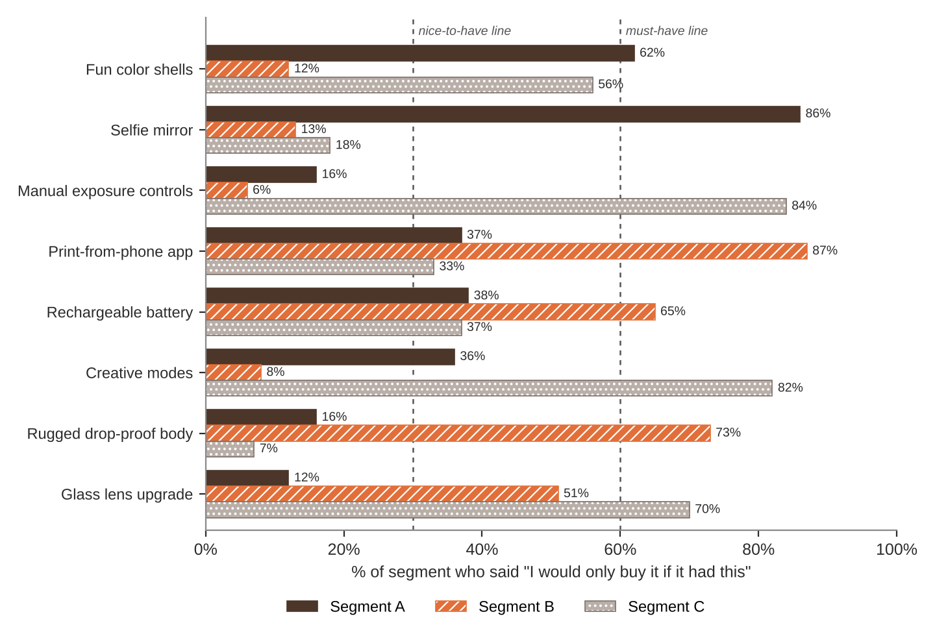
FEATURE MENU
Every feature you add raises your cost per camera. Add a feature to any version you want.
Feature | What it is | Cost to add
Fun color shells | Pastel and neon body colors | $3
Selfie mirror | Small mirror on the front for selfies | $1
Manual exposure controls | Adjust brightness and shutter speed | $12
Print-from-phone app | Bluetooth printing of phone photos | $10
Rechargeable battery | USB charging instead of AA batteries | $6
Creative modes | Double exposure and long exposure | $5
Rugged drop-proof body | Survives a 6-foot drop | $8
Glass lens upgrade | Sharper, clearer prints | $15
SURVEY RESULTS: WHAT EACH SEGMENT WILL PAY
Question asked: “If it had everything you need, would you buy it at this price?”
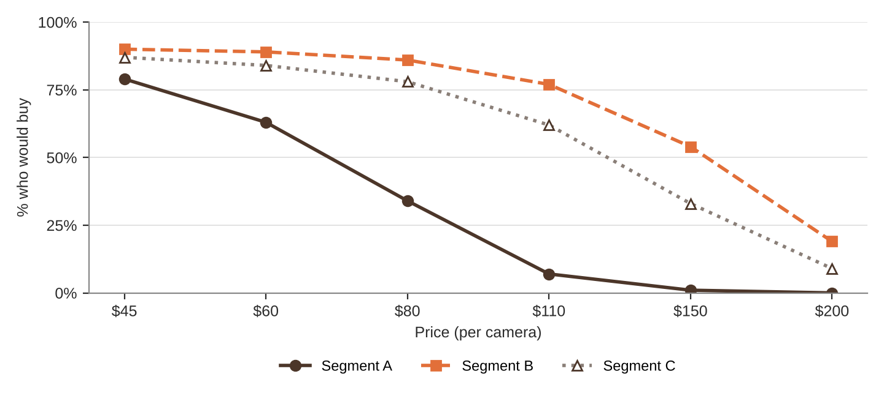
% of each segment who would buy at each price
Price | $45 | $60 | $80 | $110 | $150 | $200
Segment A | 79% | 63% | 34% | 7% | 1% | 0%
Segment B | 90% | 89% | 86% | 77% | 54% | 19%
Segment C | 87% | 84% | 78% | 62% | 33% | 9%
QUICK RULES
Must-have | A feature that 60% or more of a segment requires. Leave one out and that segment's buyers are cut in half. Leave two out and they're cut in half again.
Nice-to-have | A feature that 30% to 59% of a segment requires. Each one you include adds 5% to Fit.
Under 30% | That segment doesn't care. It adds cost and nothing else.
Fit | Start at 100%. Add 5% for each nice-to-have included. Then cut in half for each must-have left out.
Buyers | Segment size × % who would buy at your price × Fit. Round to a whole number.
Profit | Buyers × (Price − Unit cost). Unit cost = base cost + cost of every feature you added.

